MarineGEO PANELS Experiment Protocol:

Photogrammetry And Next-gen sequencing for EcologicaL Systems



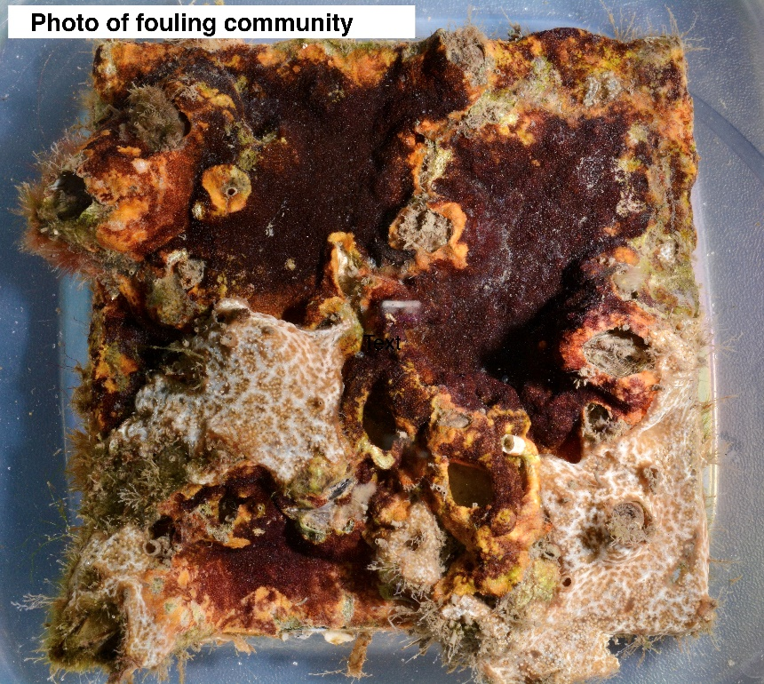

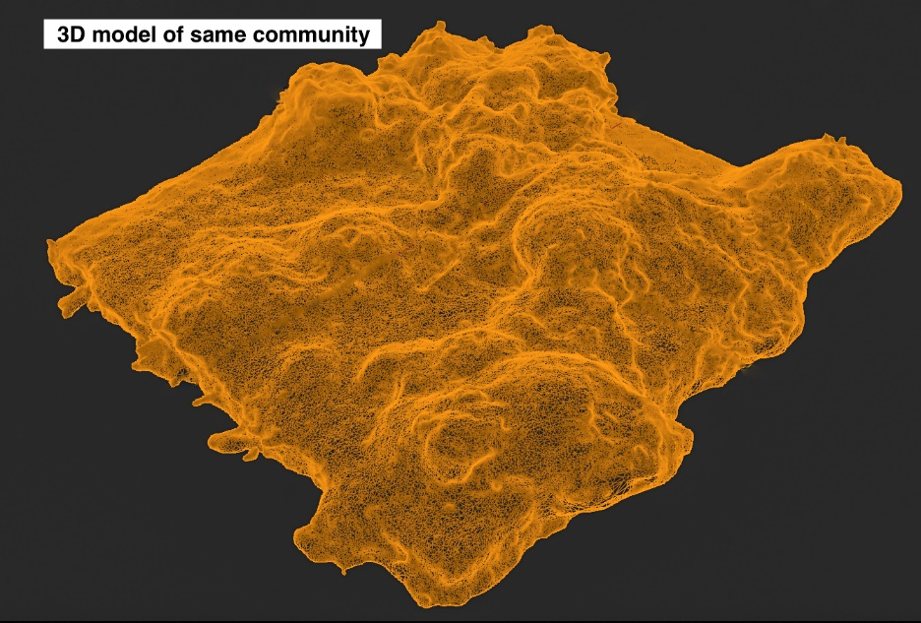

Experiment Leads: Dean Janiak (janiakd@si.edu) & David Branson (bransond@si.edu)

How to cite this work: MarineGEO PANELS Experiment Protocol: Photogrammetry And Next-gen sequencing for EcologicaL Systems. (2021) Tennenbaum Marine Observatories Network, MarineGEO, Smithsonian Institution, v1.0.





Requirements

Deployment

* 18 PVC Panels (13.7x13.7x.6 cm) – sanded with holes drilled (provided)
* 18 Bricks, plus 1 additional brick for temp logger
* ~40 m Rope
* 55 Zip ties (8”), 3 per panel and 1 for temp logger
* Zip ties cutter
* Scissors for cutting rope
* Electric blue temperature loggers (provided)
* Electrical tape or similar (optional, to mark temp logger rope)
* Field sheets

Retrieval

* Plastic containers or 5-gallon buckets for retrieval
* Paint scraper
* Balance
* Pre-weighed containers for measuring wet mass
* Field sheets

Species Identification

* Dissecting microscope
* Lab datasheet

Photogrammetry

* Turntable (provided)
* Camera
* Tripod (provided)
* Photography container (provided)
* Materials to raise panels in photo dish (e.g. extra panels, petri dishes, etc., see below)
* Labels for each panel
* Lab datasheet

eDNA Sampling

* 12 Jonah Ventures eDNA kits (provided)
* 6 gallons distilled fresh water (prepackaged, not from the tap)
* Lab datasheet



Methods

Preparation:

1. Pick a single dock or marina that is easily accessible and where use is granted by owners. Docks can be either fixed or floating but must be large enough to deploy the experiment.
2. A total of 18 fouling panels are used for the experiment. Panels do not need to be labeled when deployed and are randomly retrieved during each sampling event.

Deployment:

1. Construction of each experimental unit:
   1. Attach each panel to a brick using zip ties (8 inch). Attach a rope to the brick (Figure 1).
   2. Suspend unit in the water with enough rope so that the panel is 1 – 2 m below the mean low water line and remains entirely submerged at all times. The experimental surface of the panel should face the sea floor. Panels should be at least 1 m above the sediment even at low tide, so for floating docks, take care to ensure that the length of the line ensures the panels will never approach the sediment surface.
   3. Panels are attached to the dock either by securing rope to planks, holes, or cleats. In some cases, nails can be hammered into wooden docks for tie-off locations, though it is preferred to tie off to the existing infrastructure.
   4. All replicate units should be at least 1 m apart from each other and within the same general location to keep environmental conditions as similar as possible (sediment deposition, depth, current, etc.).
   5. Once finished, record all metadata on supplied data sheet. If you have access to a sonde or other environmental logger to measure salinity and dissolved oxygen, note the measurements and units in the data sheet.



Figure 1. Construction of experimental units

1. Deployment of Electric Blue temperature loggers:
   1. On the same dock, deploy 1 Electric Blue EnvLogger (see sampling event protocol for logger setup guidance: https://marinegeo.github.io/assets/environmental-monitoring/envlogger_documentation.pdf).
   2. Suggested deployment method: Attach your EnvLogger to one additional brick and deploy alongside the panels. Mark the line to the EnvLogger brick with electrical tape or similar to distinguish it from the panels.

Retrieval: 30, 60, and 90-days:

1. During retrieval, fill out the provided data sheets associated with the sampling event (30, 60 or 90 days).
2. Randomly choose 6 panels to retrieve. If possible, depending on accessibility to the site, retrieve and process a single panel at a time (see below).
3. Pull up panels and cut the panel from the brick, removing the zip tie.
4. Scrape the back and sides of the panel with a paint scraper to remove unwanted growth. If possible, the sides should be scraped with care to not remove organisms from the experimental surface.
5. Place each panel into a separate plastic, sealable container with fresh seawater. Panels can also be placed in buckets but take care to not dislodge any organisms. Transport panels back to the lab.
6. At the lab, place each panel in a separate container or bucket with fresh seawater and air stones. In each container, place a water-proof label (see Table 2 for examples) with year_site-code_age_replicate (ex. 2021_USA-MDA_30d_01). Contact us if you need a site code. All 30 day photos are labeled 01-06, 60 day photos are 07 – 12, and 90 day photos are 13 – 18. These labels stay with the panels during all steps. **Please be very careful in labeling the units and do not change the assigned codes in any way.** This will greatly streamline analysis and data processing and will get you a published paper faster!
7. At the 90 day retrieval, follow the instructions in the EnvLogger handbook to download your temperature data.

Lab Photography:

1. General camera settings:
   1. High quality jpg (Minimum 12 MP (Phone cameras are not acceptable))
   2. No Flash
   3. No color correction (e.g., underwater mode)
   4. Auto-focus
   5. Rule of Thirds Grid on display (see camera display, Figure 5)
2. Shake the panel in water to remove any lose sediment prior to taking photos of it.
3. Place a panel and its label in the provided container filled with clean seawater. The panel will need to be elevated in the center of the container so it is near the water surface (Figure 2). We suggest placing petri dishes or extra panels beneath the panel to help elevate.

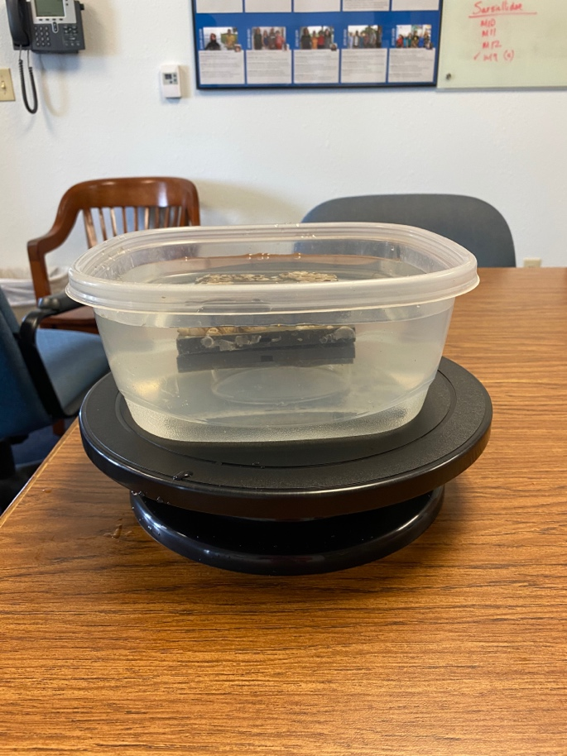

Figure 1. Submersed tile in photography container on turntable.

1. Take several top-down photos of the panel (Figure 3). Check for accurate focus and no glare from overhead lights. Use the reflector provided in the kit to help remove glare from overhead lights by orienting the reflector in such a way that glare is removed. Panel should be centered and fill most of the viewfinder. These images will be used to assess percent cover of taxonomic groups. **Make sure label is visible in the photo.** Make sure to write the image numbers for this set on the data sheet.

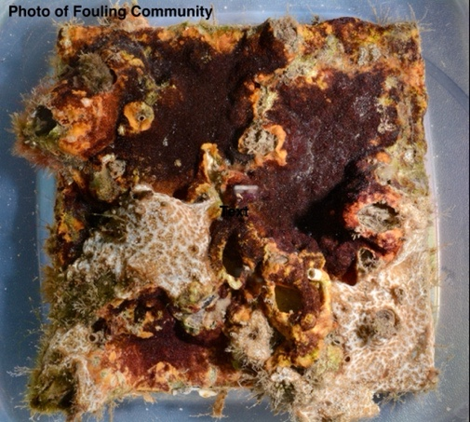

Figure 2. Top-down image of panel.

1. Set up tripod and turntable, placing photography dish in center of turntable (Figure 4). Orient the reflector is such a way that it removes all surface glare when taking the photos.

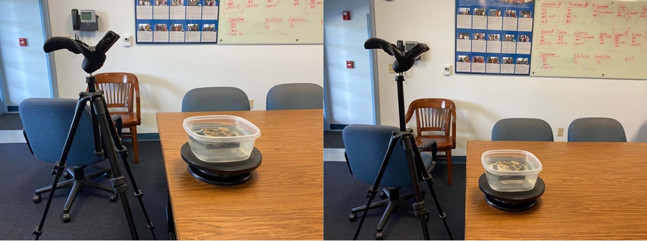

60o

45o

Figure 3. Tripod with camera aimed at panel on turntable.

1. Center the panel in the rule-of-thirds grid on the camera display (common feature for most cameras) and fill the center square by careful placement of the tripod and camera, and then zooming in to the panel (Figure 5).

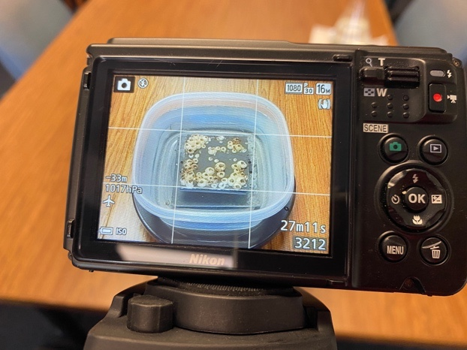

Figure 4. Panel centered in viewfinder.

1. PRIOR TO TAKING PHOTOS, SLOWLY SPIN TURNTABLE MAKING SURE PANEL IS ALWAYS IN VIEW, NOT BLOCKED BY THE CONTAINER. THIS ALSO WILL PROVIDE AN IDEA ON THE ROTATION DISTANCE NEEDED TO GET ~40 PICTURES PER ANGLE. It is important to make sure that seawater in the photography dish is clean and CRITICAL that no glare occlude the image at any angle.
2. To construct 3-D models of communities, capture two series of photos, one at roughly a 45 o angle, and one at a 60 o angle. Keep the tripod stationary throughout. At each angle, rotate the turntable in small increments and take a photo between rotations. This equates to 10 photos per 90 o turn of the turntable (20 per 180 o). Approximately 40 photos should be taken at each of the two angles, providing a cumulative 80 photographs per panel. If you are unsure about the angles and the rotation, it is always safer to take more pictures than fewer.
3. Repeat steps 3-8 for each of the panels.
4. When finished, download photos from the camera, and make sure to place all photos into a folder, labeled with the exact same code as the panel ID and containing only photos from that panel (see Table 1). Do not alter the original image in any way, including resizing, cropping, or color correction.
5. Top-down photos should be in a separate folder with photos labeled by their ID (see Table 01).
6. Place all photos in a folder labeled by year_site (ex. 2021_FTP). Within that folder there are 2 folders labeled “topdown” and “3D”. Within the topdown folder should be all top-down photos with each panel labeled in the following format: year_site_age_replicate (ex. 2021_FTP_30d_01, use replicate numbers 01-06 for 30d, 07-12 for 60d, and 13-18 for 90d.

**Table 01. Example of naming scheme**



Quantifying Community Diversity:

1. After photography, place each panel and label under a dissecting microscope and document the presence of all sessile species on the surface using the data sheet. Do not include mobile fauna, but do include tube-builders. If species are unknown, give each a morpho-species identification (e.g. orange colonial tunicate 01). A primary goal is to correlate biodiversity with structure complexity and so it is important to have a count of how many species are present within a community at each successional age.

eDNA Sampling:

1. After a species list is obtained from all panels, randomly select 3 panels for eDNA sequencing.
2. Using the paint scraper, scrape the entire community off each of the remaining 3 panels into separate pre-weighed containers and take the total wet mass that was on each panel. Record these data on the provided data sheet. Save all tiles for future experiments.
3. Put on sterile gloves (latex or nitrile).
4. Fill the lower lid of three clamshell sterile plastic containers (included) with ~1000 mL of distilled fresh water. Do not substitute a different kind of container because the water volume and container material must be standardized for comparison. If you are exactly measuring the amount, be sure to use a sterile container to measure and transfer the water; do not use a container that may have held seawater (to limit contamination).
5. Place one panel and its label face-down in a one of the clamshell containers so the community is against the bottom and completely submerged (or as close as possible). Repeat for each of the three panels.
6. Fill the lower lid of a fourth empty container. This will be used as a negative control.
7. Close and seal the containers by attaching the upper lid to the lower lid. Allow the containers to sit for X hours. (exact time forthcoming based on preliminary trials)
8. After the panels have soaked for the required time, open the eDNA kit in preparation for sampling eDNA. Each kit has detailed instructions as well as a code printed on the foil packet that goes with each sample. Carefully write down the kit code that goes with each panel code on the data sheet. It is imperative that you record the panel code and the kit code so that we can link the information later.
9. Remove and replace the sterile gloves.
10. Using the syringe provided in the eDNA kit, open the first container and use the plunger to fill the syringe.
11. Attach the provided filter and gently but forcibly press the water through the filter.
12. Repeat until it is no longer possible to pass any more water through the filter (i.e., the filter is clogged). In tests, this was < 0.25 L of water. Record the total volume of water passed through each filter on the provided data sheet.
13. Remove the filter from the syringe. Using the provided syringe prefilled with preservative, attach this to the filter and slowly depress the preservative into the filter.
14. Place the preserved filter inside the prelabeled foil packet, again ensuring that the panel code and the kit code on the packet are recorded.
15. The kits come with a pre-labeled mailing slip so that the preserved filter can be mailed back to the company (Jonah ventures) for processing and bioinformatics. Please return the filter package to Jonah Ventures as shown on the label, **not** to the Smithsonian.
16. Remove and replace the sterile gloves and repeat steps 10-16 for the remaining 2 panels and the blank control.
17. Mail the four sealed packets to Jonah Ventures according to the instructions.



Data Submission

1. Enter all data and metadata into the provided data entry template. Each template is an Excel spreadsheet. Please provide as much protocol and sample metadata as possible. Use the “notes” columns to provide additional information or context if a relevant column doesn’t already exist. Please do not change names or order of existing columns.
2. Submit your images and the data entry spreadsheet to the Dropbox folder that has been shared with you. Maintain the same folder structure for storing the images as specified in the “Lab Photography” section in the Dropbox folder. If you do not have enough storage space with Dropbox to upload the images, email us to receive a “Data Upload” Dropbox link that will allow you to send us the images.
3. Submit the Electric Blue EnvLogger data based on follow-up instructions.

***You’re finished! Thank you for collaborating with Smithsonian MarineGEO—we look forward to following up as the data are processed and analyzed.***

Please contact [marinegeo@si.edu](mailto:marinegeo@si.edu) for protocol questions including questions on species identifications.